**NTUT**

**Operating System homework_2**

**指導老師 : 段裘慶 教授**

**班 級 : 電子所甲組**

**姓 名 : 臧英宏**

**學 號 : 109368085**

**民國109年十二月一日**

1. Executing *multiple threads* can speed up the running of programs. Let us conduct experiments to practice the features and skill of *multithreading*.

You need to *code two different styles of programs* to compute the following “matrix multiplication” in the same programming language(e.g. C language).

*C*100X100 = *A*100X60 X *B*60X100

[*aij*] = 12.2*i* - 3.8*j* **,** [*bij*] = 65.1 + 3.3*i* – 20.2*j*

* In the ***first*** program, you just code it using the traditional ***for-looping*** skill.
* In the ***second*** program, you need coding it by using ***multithreading*** skills.

**Q1:** Point out the *major parts* in the threaded program to highlight its differences with *for-loops*.

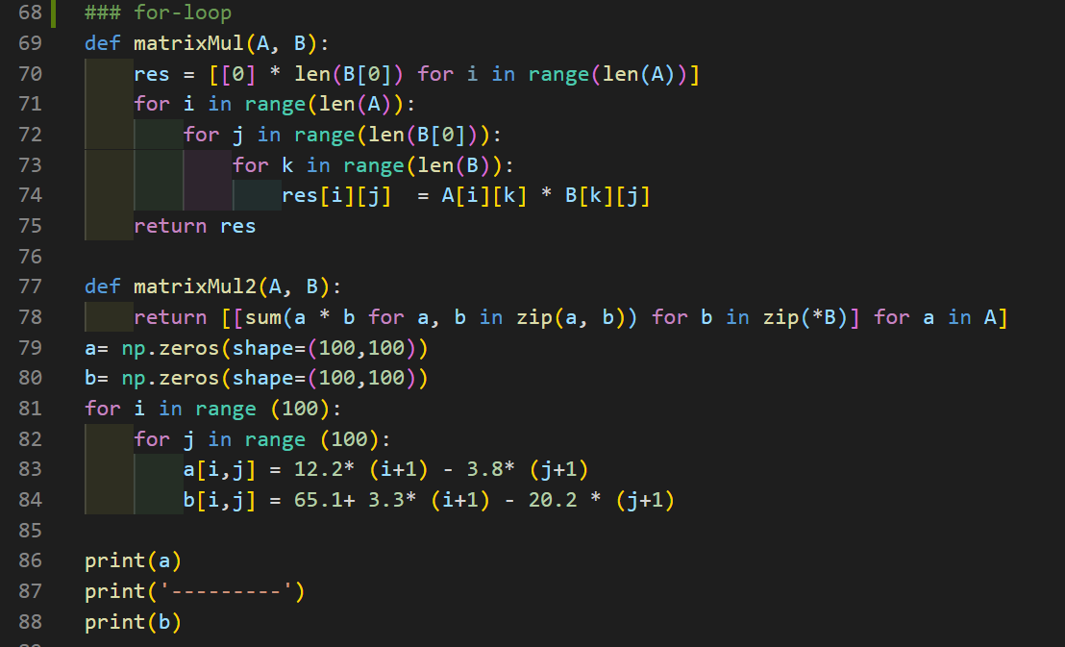

(a). for-loop

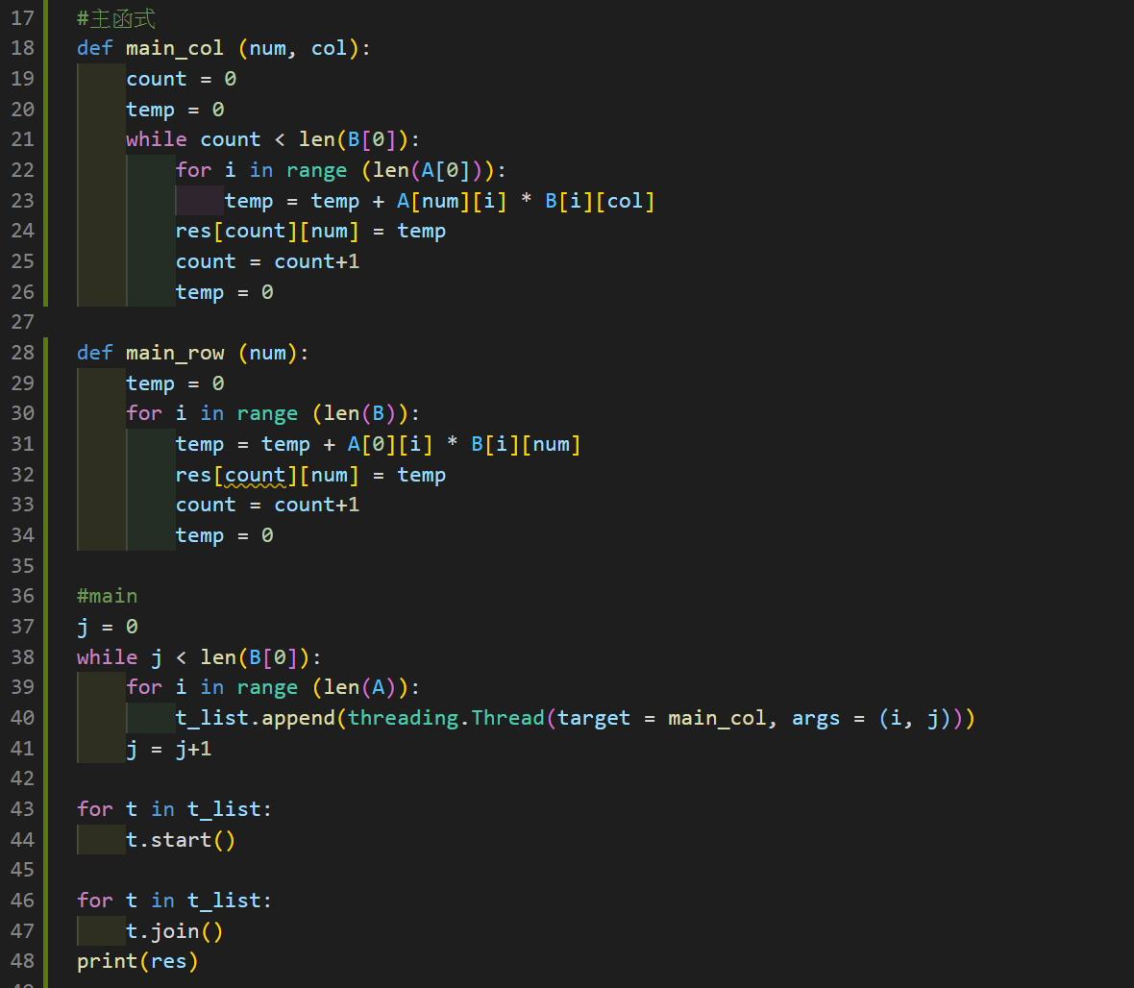

(b) threading

Threading需要額外宣告threading.Thread來產生執行緒，再將執行緒排程同步執行，最後待所有執行緒結束後輸出最終矩陣。

**Q2:**  Record your *experimental results* atleast *3 rounds* of execution in the below table, and state how you can count the running time of programs in ms/us.

**Q3:** State your *comments* after coding *threaded* programs for this exercise.

|  |  |  |  |  |  |
| --- | --- | --- | --- | --- | --- |
| **Coding Skill** | **Lines of**  **Code** | **My PC/NB** | | | **Average Ex-**  **ecution Time** |
| **1-round** | **2-round** | **3-round** |
| **【A】**  ***For-loops*** | 9 | 2873(us) | 2238(us) | 2957(us) | 2689(us) |
| **【B1】*100*100 cells***  ***Multithread*** | 24 | 62498(us) | 68623(us) | 67236(us) | 66119(us) |
| **【B2】*100 rows***  ***Multithread*** | 21 | 4325(us) | 4723(us) | 4851(us) | 4633(us) |
| **【B3】*100 cols***  ***Multithread*** | 18 | 2965(us) | 2037(us) | 2144(us) | 2382(us) |
| **Differences**  **【B1 - A】** |  | 59625(us) | 66385(us) | 64279(us) | 63430(us) |
| **Differences**  **【B2 - A】** |  | 1452(us) | 2485(us) | 1894(us) | 1944(us) |
| **Differences**  **【B3 - A】** |  | 92(us) | -201(us) | -813(us) | -307(us) |

*Note that you need to take some pictures of the running screen on LCD, and appendix your two *source codes* in your report.

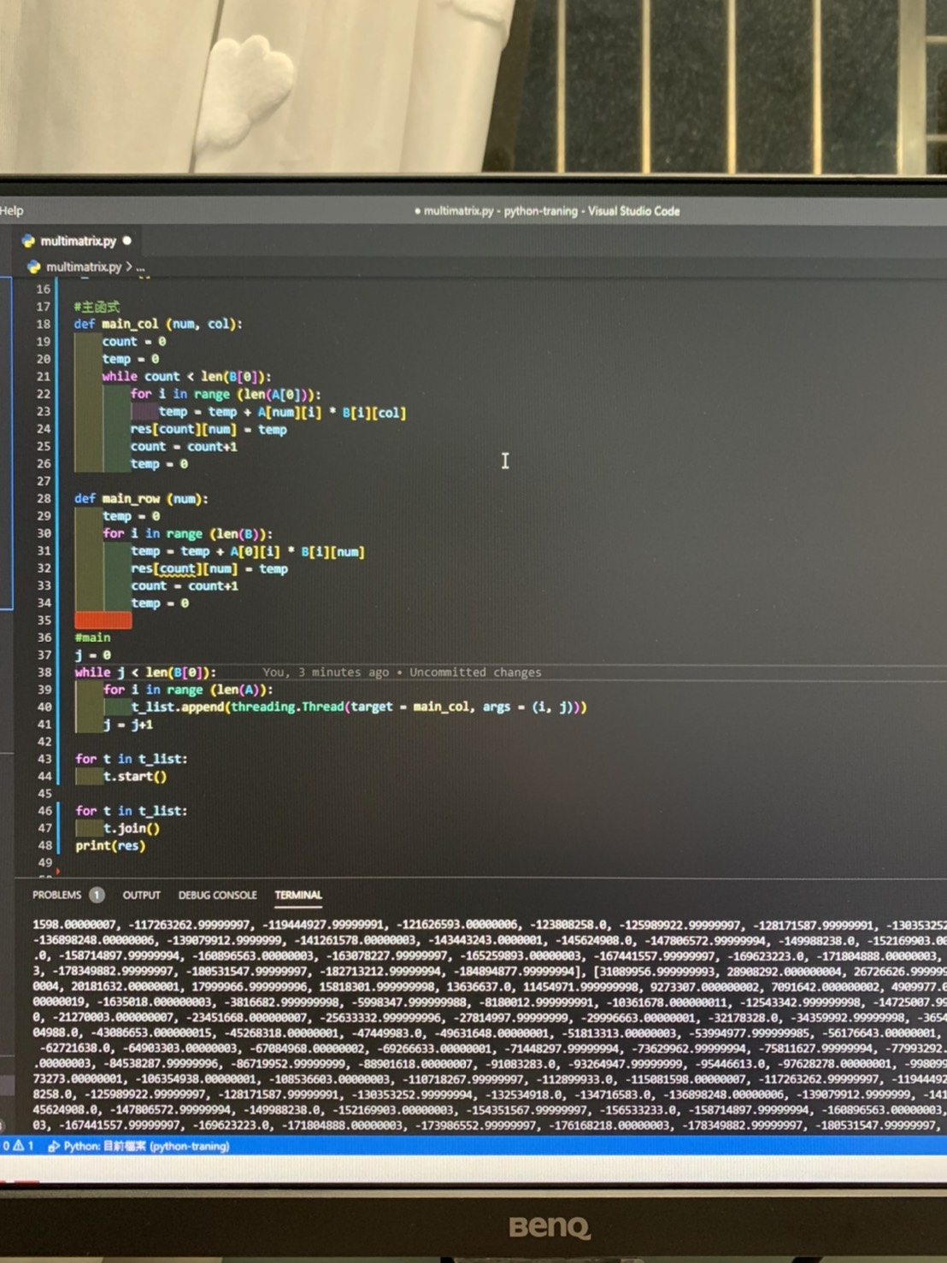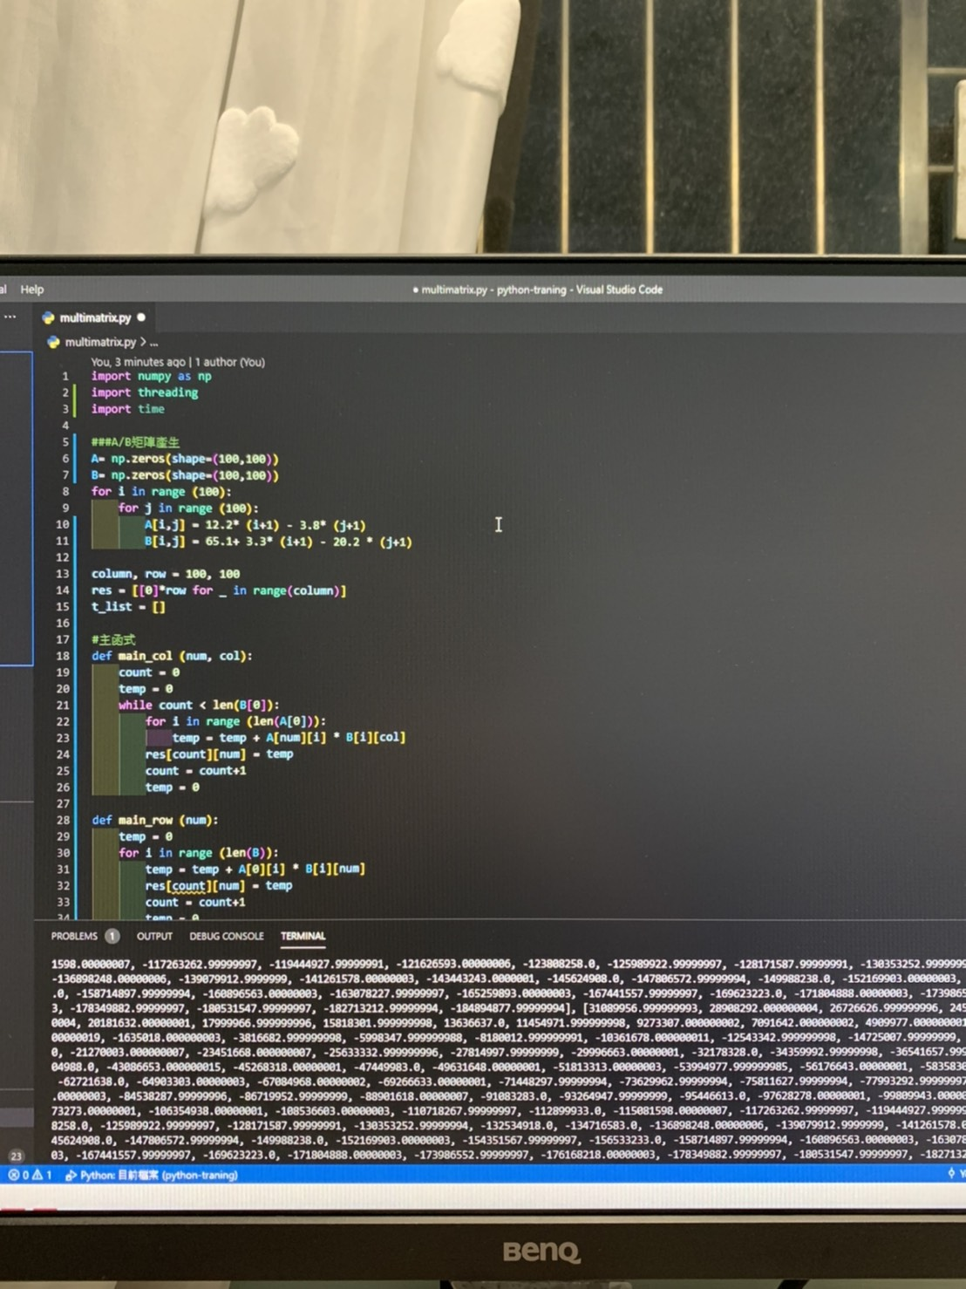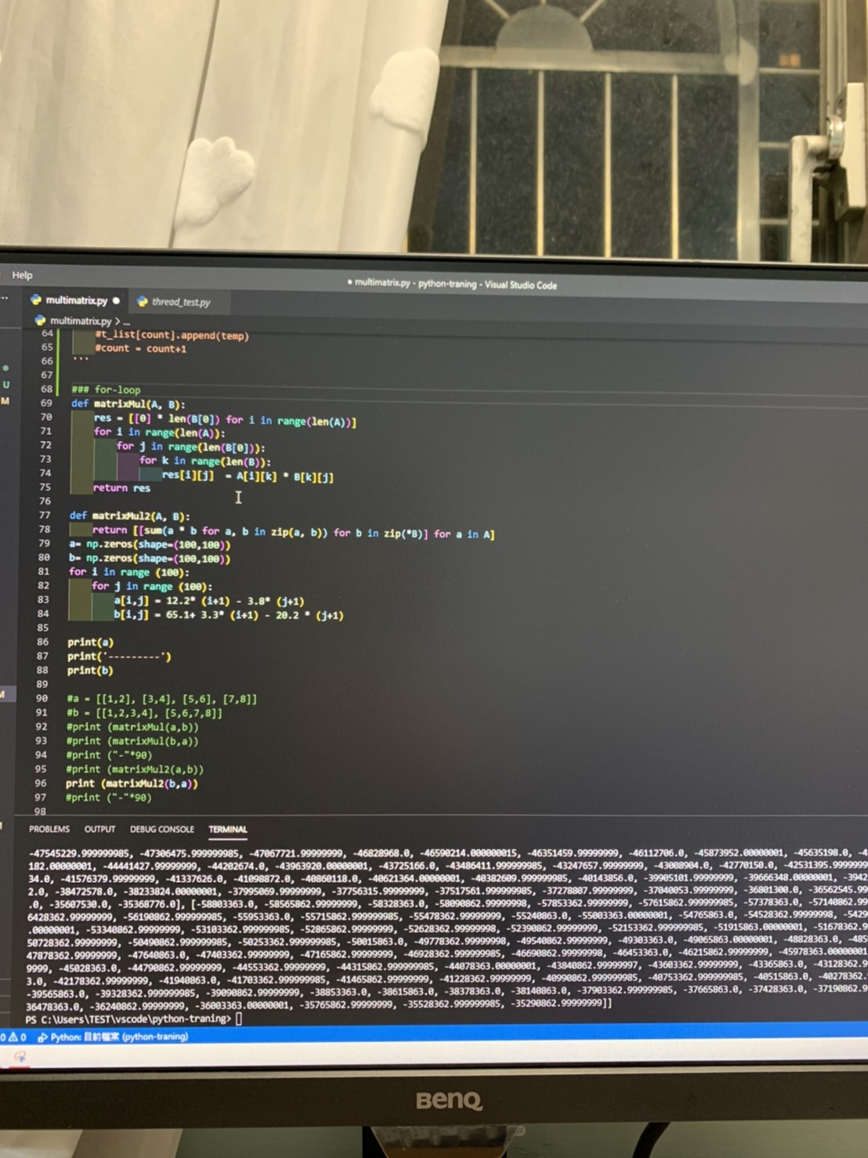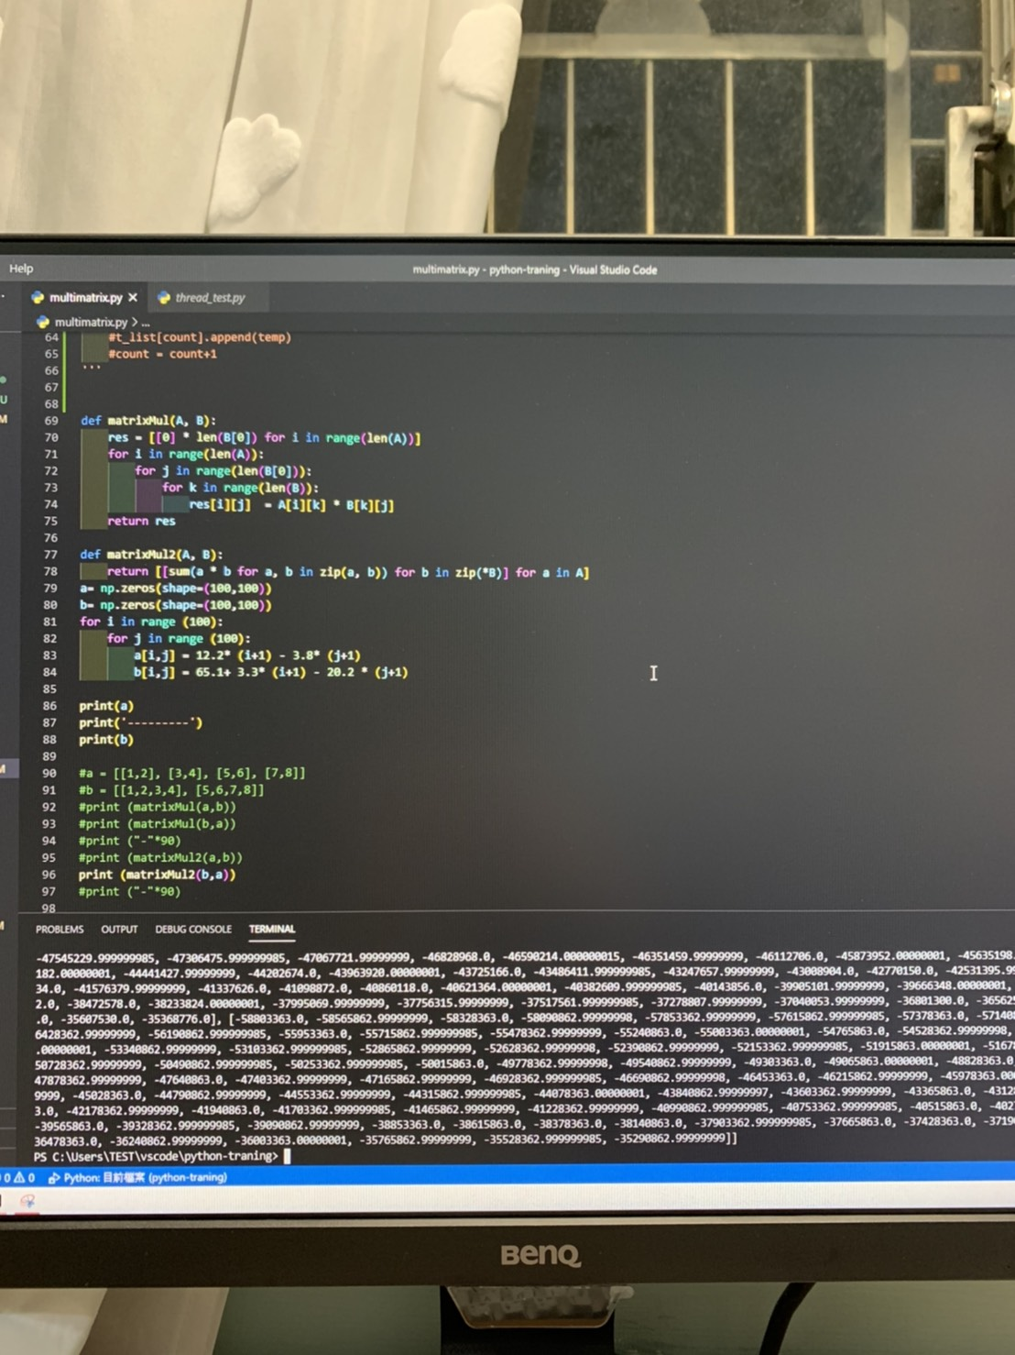

***Due date :* Dec.2, 2020.**

心得

透過本次作業進行執行緒的實作，原先對thread的瞭解僅限於書本上，說到底實際上的應用，在課程前還真的沒有試過，經過這次的作業練習上網查找了不少執行緒的程式寫法以及應用，對於threading印象更加深刻，也更能瞭解其位於電腦當中multithreading的意義與目的，剛好可以應用在OS課程上，實作與理論的相輔相成，使我對於這個單元更加熟悉。